

**Document Information**

|  |  |  |  |  |  |
| --- | --- | --- | --- | --- | --- |
| **S.No** | **Version No.** | **Prepared By** | **Approved By** | **Date & Month** | **Description** |
| **1** | **Initial** |  |  |  | **Draft version** |
| **2** | **1.1** |  |  |  | **Draft version** |
| **3** | **1.2** |  |  |  | **Draft version** |

|  |  |
| --- | --- |
| **Document Name :**SOP for Check MK Installation in GCP Servers | |
| **Project :** TVS & Sons | |
| **Subject**: | |
| **Document No.: TVS-DC-004** | **Version :** 1.2 |
| **Prepared by: Nagarajan, Precision Infomatic** | Date : 18 Nov 2017 |
| **Reviewed by:** | Date : |

**TABEL OF CONTENTS**

1. Login to the GCP Console………………
2. Login to the Check Mk Server which I have Configured in the GCP…………………………
3. Add New Host ……………….
4. Enter the Host Name…………………….
5. Change the Port Number which you have allocated for the server**……………….**
6. Create Host Specific Rule……………………
7. Default Services – Cpu, Memory, Uptime, Disk, Disk IO Summary………………………

Step 1: Login to the GCP Console, Add the Tag **“prd-checkmk-nat-fw**” in the server which we need to install the check in the portal level.

**Click On EDIT**

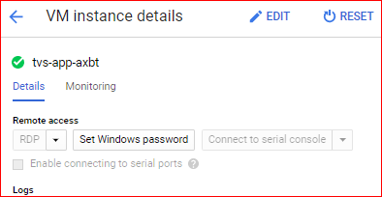

Navigate to network Tags and add the tag and Save

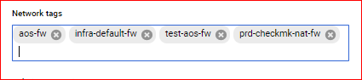

Step 3: Kindly Install the Check Mk ( .exe File ) In all the servers which we need to Monitor Via Check_Mk

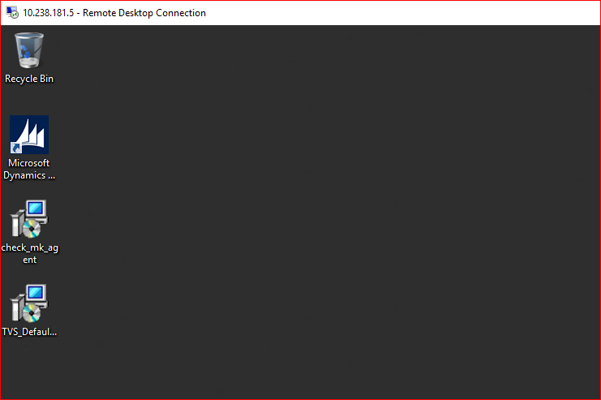

Then Login to the Check Mk Server which I have Configured in the GCP

**Ip Address – 10.238.150.11**

**Password – TV$!y3ng@R**

**Open the command Prompt in Administrative Mode and run the Following Command one by one**

**netsh interface portproxy add v4tov4 listenport=6517 listenaddress=35.200.132.120 connectport=6556 connectaddress=10.238.170.44**

**netsh interface portproxy add v4tov4 listenport=6517 listenaddress=10.238.150.11 connectport=6556 connectaddress=10.238.170.44**

**netsh interface portproxy show all**

**Kindly change the Ip and port number as for the consecutive servers.**

**For example – I have used the port till 6517, kindly use the port 6518 for next server and change the IP of the server also.**

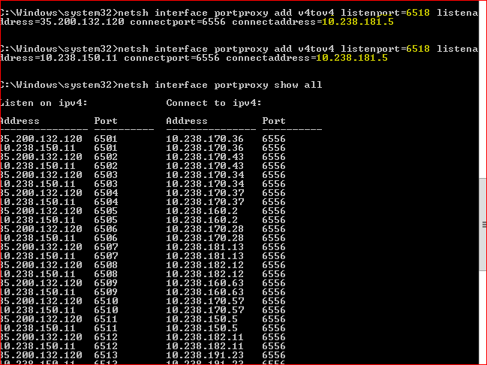

**Step 5:** Navigate to Check_MK Console and click on Host and then **Click on TVS Folder and then click on Add New Host.**

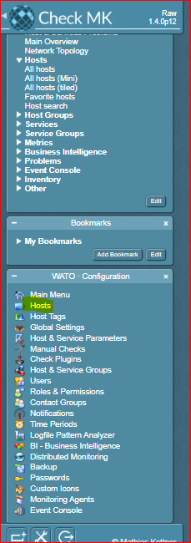

Step : 6

Enter the **Host Name** and Click on Ipv4 and enter the Ip **“34.93.178.183”, and Click on Save and test.**

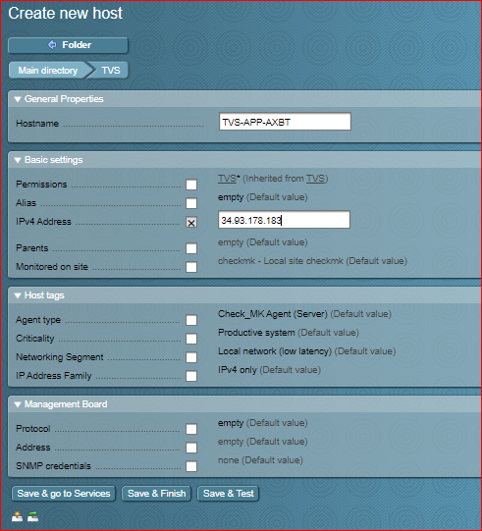

**Once Clicking on Save and Test it will navigate to the next page, in that kindly change the port range that you have set above.**

**Important Note**

Kindly Confirm the port number and exact server name which you have configured.

Kindly check ping and Agent is communicating

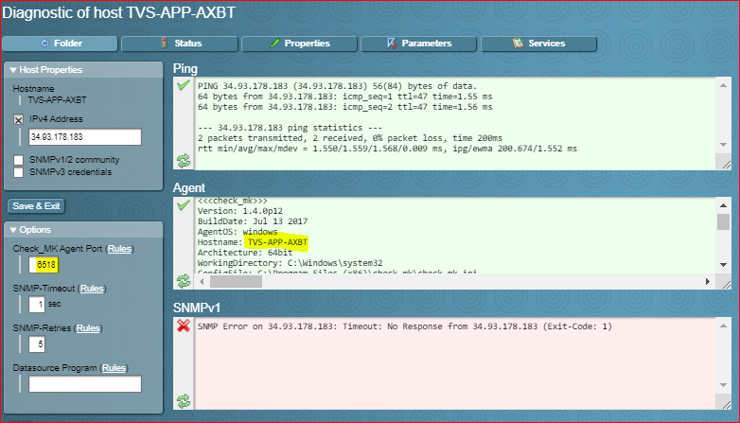

**Step -7 Once it is successful kindly click on Save and exit. It will navigate to another page, there click on Parameters.**

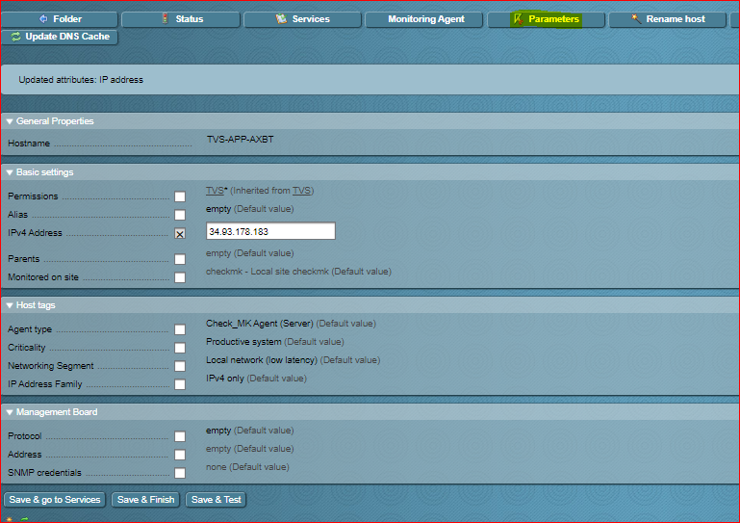

**And change the Port Number which you have allocated for the server. For that click on “TCP Port Connection in Check_MK” .**

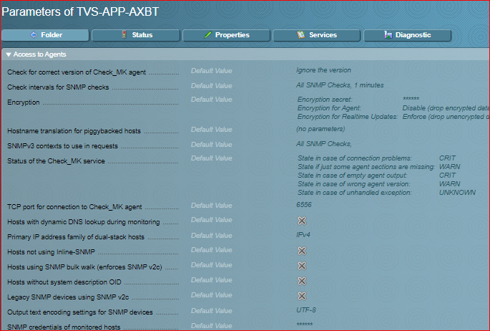

**Which Navigate to another page. There click on “Create Host Specific Rule”**



**There enter the Server name and Port Number for that Server and Click on Save.**

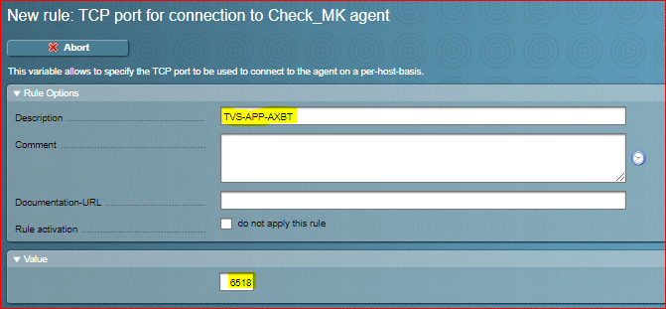

**Then click on services. Which on the top, Which Navigate to Another page, there add the desired services that we need to monitor.**

**Default Services – Cpu, Memory, Uptime, Disk, Disk IO Summary.**

**Click on Green Icon to Add the service. And the click on the 9 Changes to activate the Changes that have done so far.**

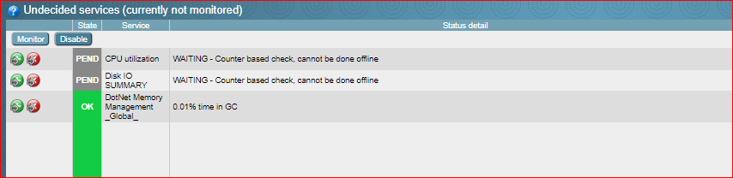

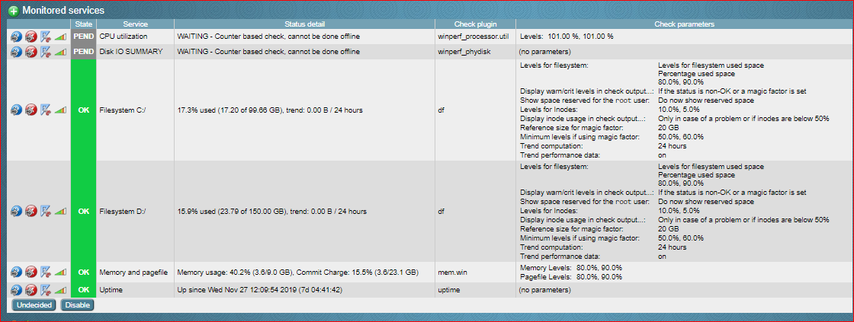

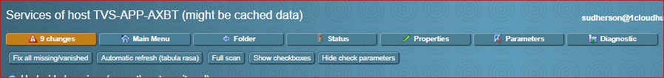

**Then Navigate to Host and click on the server and click on reschedule check to enable communication.**

**At last check in the portal whether the Ram CPU and Disk are correct.**